Department of Humanities and Social Sciences
IIT Bombay
HS 307: Introduction to Sociology Mid-semester Examination
Total Marks: 30 14 Sep 2010 Time: 2.00 – 4.00 PM
Roll No. ____________________________

Section A:
Objective Type: This sheet is to be returned to the invigilator after marking the answers. 30 minutes are allotted for Section A. Each answer carries 0.5 marks (0.5 x 20 = 10 marks)

I. Write your answers in the blank spaces provided
- Who said this? “Collective mobilization, Method of Organization and Ideology constitute the basic features of a Social Movement” _______________________________?
- The categorization of political violence as ‘turmoil’, ‘conspiracy’ and ‘internal war’ has been made by ___________________ in the book ___________________________?
- Alain Touraine’s Identity Oriented Paradigm of New Social Movement studies approach is discussed in his book titled ________________________________.?
- Trade union movement is a __________________ type conflict in Touraine’s NSMs paradigm.
- Mothers against Drunk Driving (MADD) is a ________________________ type of social movement.
- The protest against Coca-Cola factory in Plachimada as a symbol of the struggle against globalization is otherwise called as ______________________________?
- “Development’ is defined in terms of social, is much concerned with the opportunities that people have to improve the quality of their lives”…. This definition is given by ___________________________.
- Defining cultures as “webs of significance”, Clifford Geertz states that in understanding the term ‘culture’ we need to sort out the “_____________________ ____________________________________”
- According to Max Weber, Sociology is a science which attempts the “_____________________________________ of social action”
- According to Peter Berger, since the essential nature of "society" is "hidden" by authoritative/cultural factors, sociologists need to develop the “art of mistrust”, and, the abilities of “looking behind”, and “_______________________”
- The position of the Queen of the United Kingdom is an example of __________________ status.
- The inability to perform a role upto expectations because “expectations are too high”, there is “inadequate motivation/preparation for a role”, or there is “role ambiguity”–these can lead to ___________________ .
- The process by which individuals learn the culture of a society and assimilate it, is referred to as ______________________.
- Undergoing training for a new job can be termed as “_______________________ socialization”.

II. Answer True or False
1. According to Pierre Bourdieu, a person’s class position, education or profession can influence his or her judgement of ‘taste’.
2. Culture can be defined as learned behavior as distinct from that which is given by nature, or biology.
3. For sociologists, trying to understand or explain ‘why” things go wrong (eg. crime, discrimination) is a ‘sociological problem’, and not a ‘social problem’.
4. The method of ‘Sociological Imagination’ makes a distinction between ‘the personal troubles of milieu’ and ‘the public issues of social structure’.
5. Conflicting obligations within a particular status can lead to role conflict.

Department of Humanities and Social Sciences
IIT Bombay
HS 307: Introduction to Sociology Mid-semester Examination
Total Marks: 30 14 Sep 2010 2.00 – 4.00 PM

Write answers for Section B and Section C on separate answer booklets.
Section B: Write short answers for any two of the following: (3 X 2 = 6 marks)
(Word Limit: 200 words)

- What are the core concepts of ‘Social Development’?
- Explain the two major elements of New Social Movements theory proposed by Alain Touraine?
- What are the chief characteristics of New Social Movements?
- Why is the period of 1970s particularly referred to as the period of ‘New Grassroots Movements’ in India? Give one example.

Section C: Answer any two of the following in 300 - 400 words: (7 X 2 = 14 marks)

- Read the short newspaper clip (below) about the Hindi film actor Govinda. Why does the article state that the “elite began to appropriate him” as his popularity grew? Explain why you think “from being infra dig (beneath one’s dignity) it became fashionable to be a Govinda fan”? While answering these questions define the terms ‘high’ and ‘low’ culture’, and explain why struggles take place in society to influence the judgement of ‘taste’.
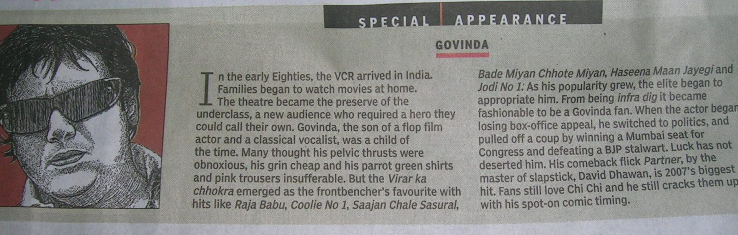

- Explain C.H. Cooley’s theory of socialization, especially his idea of the ‘looking glass self”. Using examples from Indian newspaper / television advertisements, describe how the media attempts to influence our ideas of the self.
- Does Pierre Bourdieu’s concept of “habitus” provide a better way of understanding individual behaviour and personality? Give reasons for your answers. Using examples, explain what Bourdieu means by the following two aspects of the human habitus – a. ‘classificatory and assessment propensities’; and b. ‘embodied phenomena’.
- Explain the concepts of ‘role conflict’ and ‘role strain’. Below is a cartoon which depicts the behaviour of some police officials in the aftermath of Hurricane Katrina in the American city of New Orleans. From this illustration what can we understand regarding the concepts of role conflict, role strain, and role abandonment during a crisis or disaster?
